Hi ,

I have completed all the tasks assigned to me in the assignment . I did not have time to create a much appealing UI because I have work today and I didn’t have time to focus on that area but the tasks in the assignment has been fulfilled .

<https://github.com/merntest/pinoy-code> (this is the code of the current react website iam working on it’s a UI I designed and coded , its responsive for all screens too.)

so the first task is to login with the API that was given to me and here is the UI:

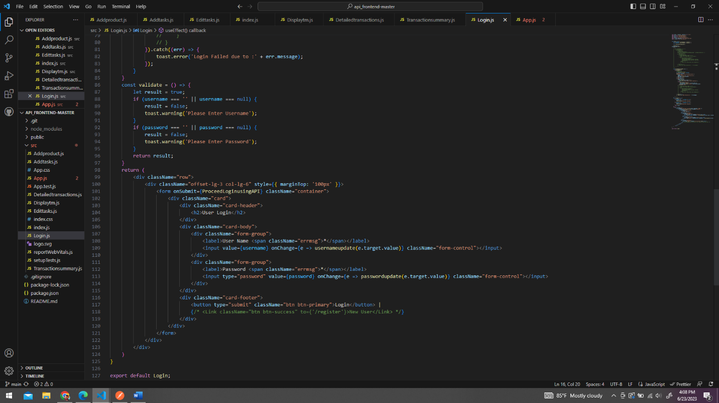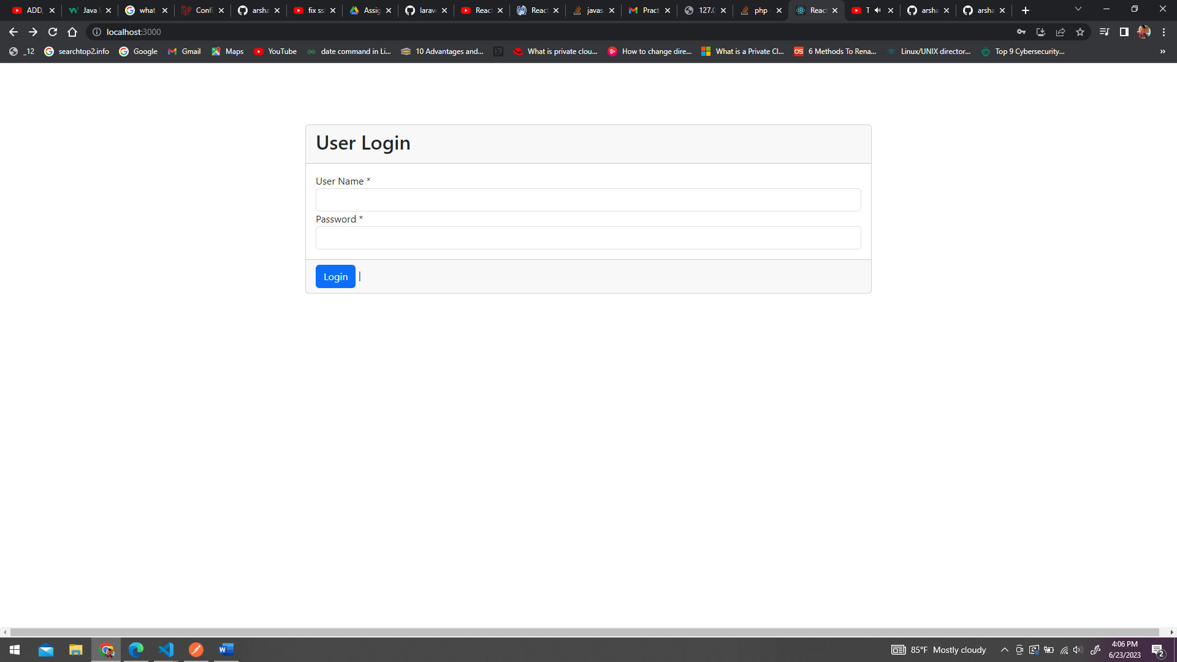

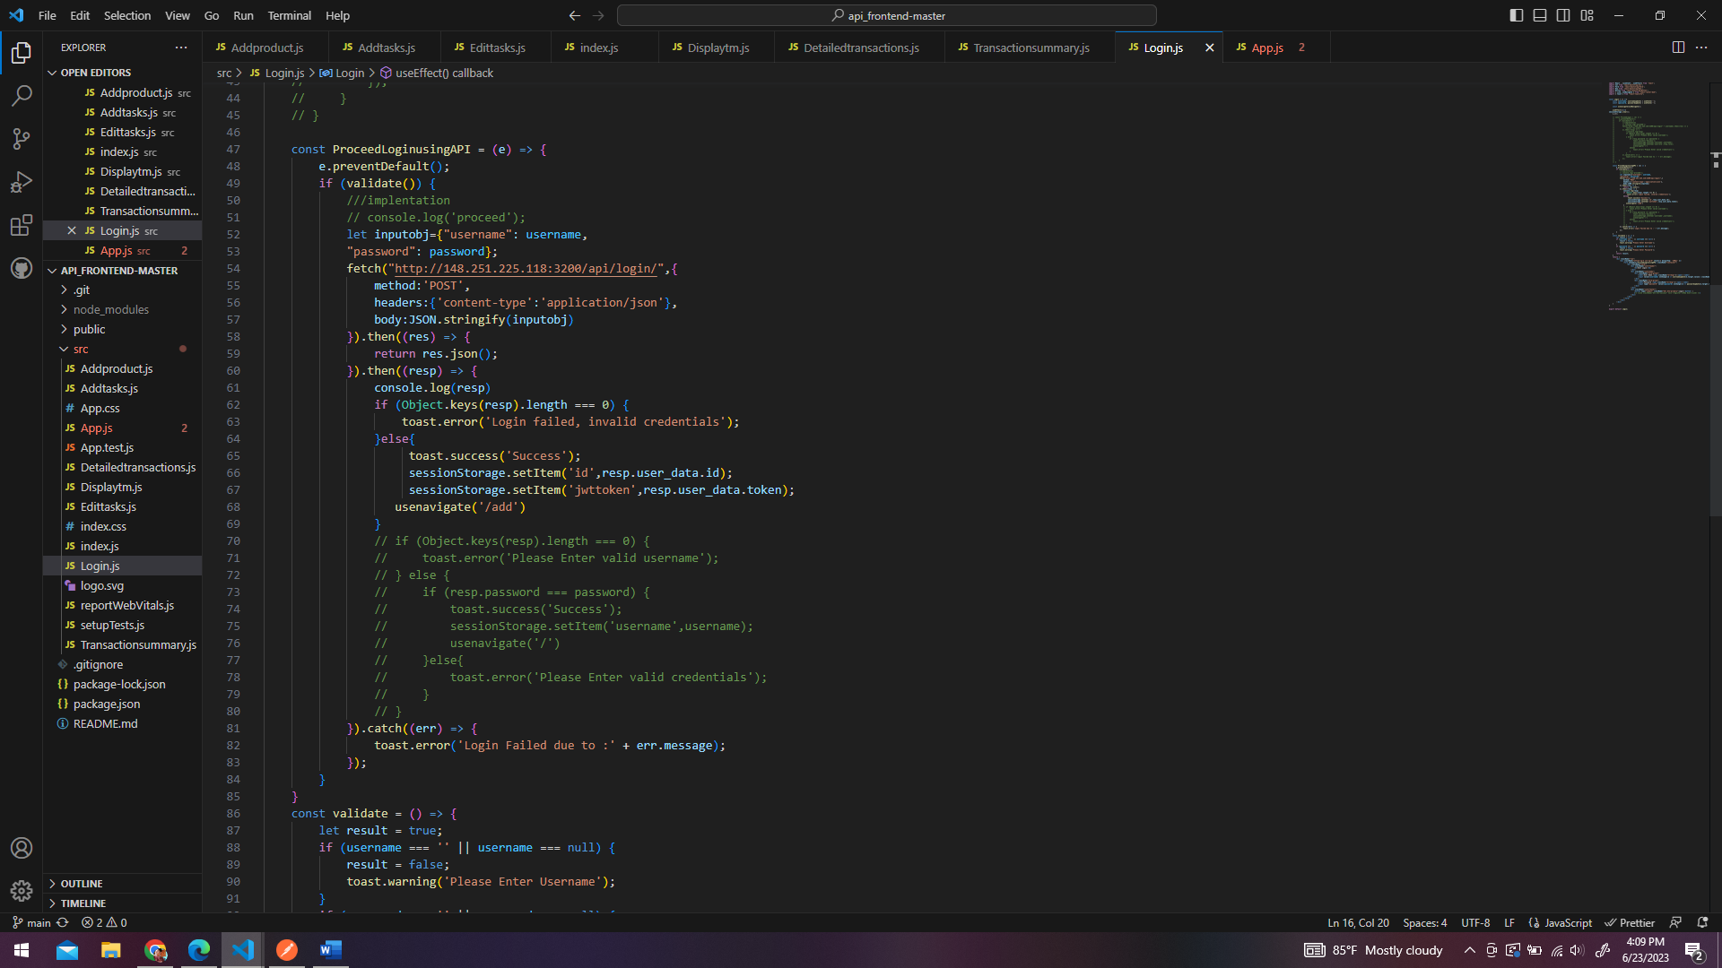

So the after taking the details in a form the details are validated and passed to check with the API to login to the system , the id and the access token is stored using session storage and passed onto the next page .

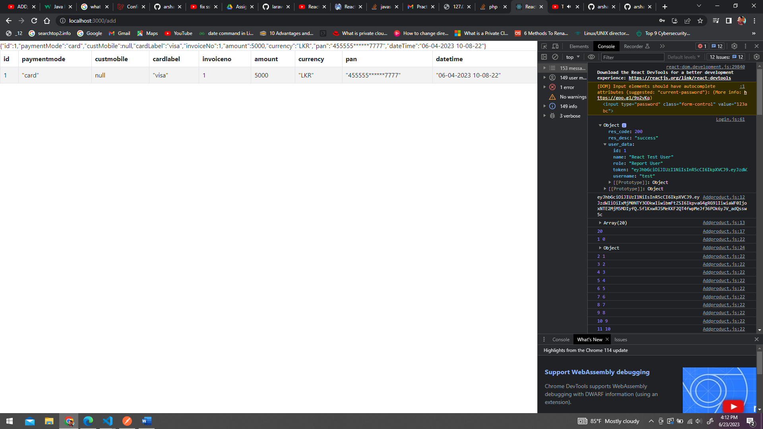

The login is successful after entering the correct credentials. And then the user will be navigated to the report page.

I assumed this page is only suppose to display the details of the entered user using after fetching all the transactions I stored the number of transaction into a variable and I looped through every transaction and got the id of each transaction and compared with the id in the session storage and displayed the details of the particular user both in json and in table format.

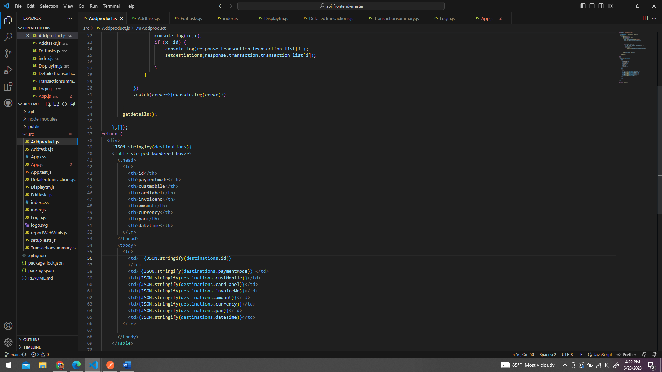

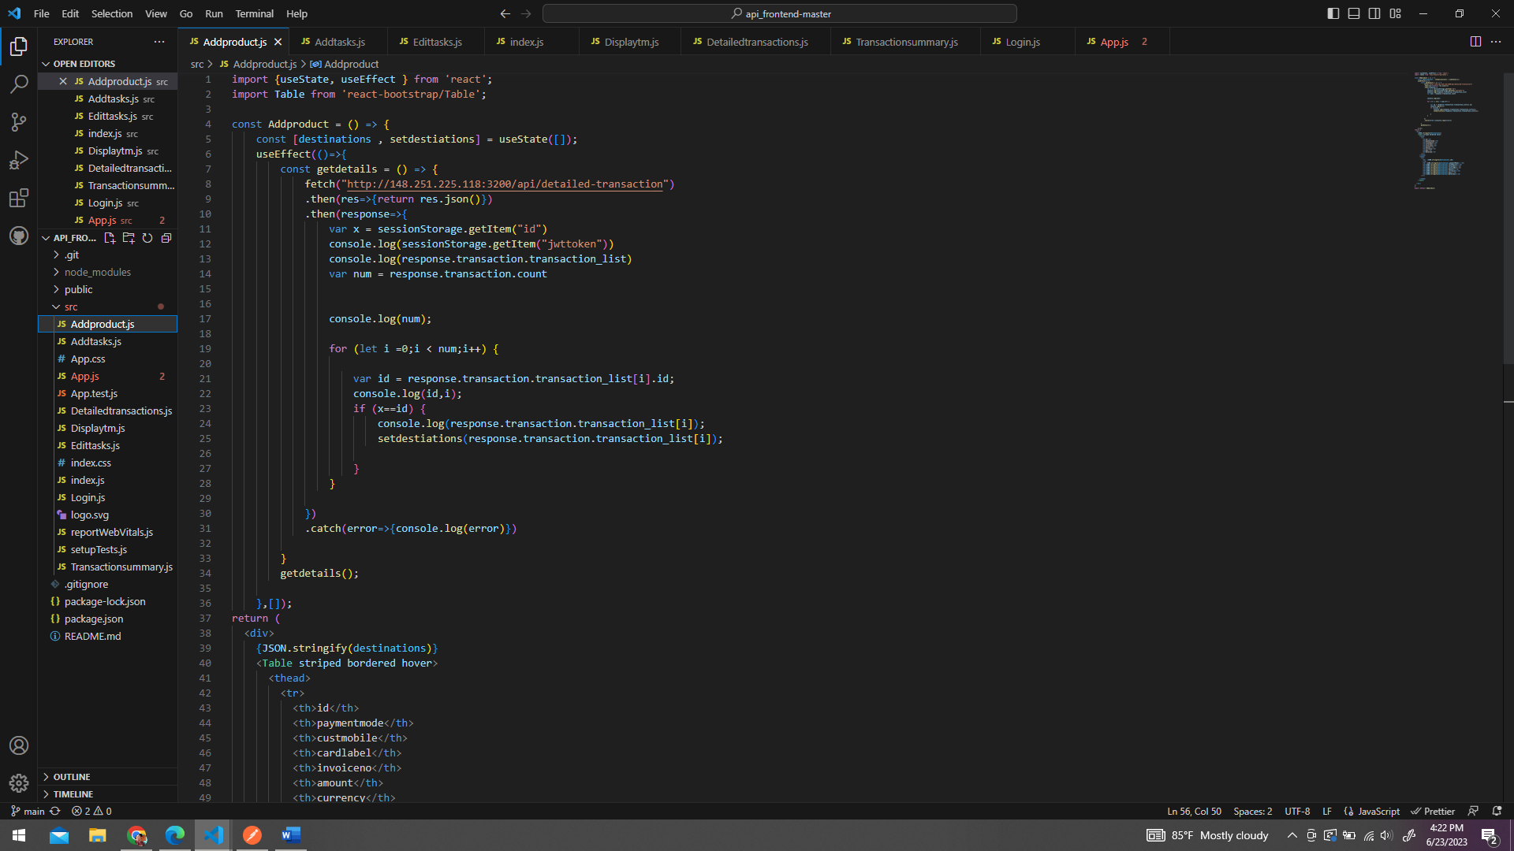

The output can be seen in the earlier image. If the id isn’t matching no details will be displayed.like this:

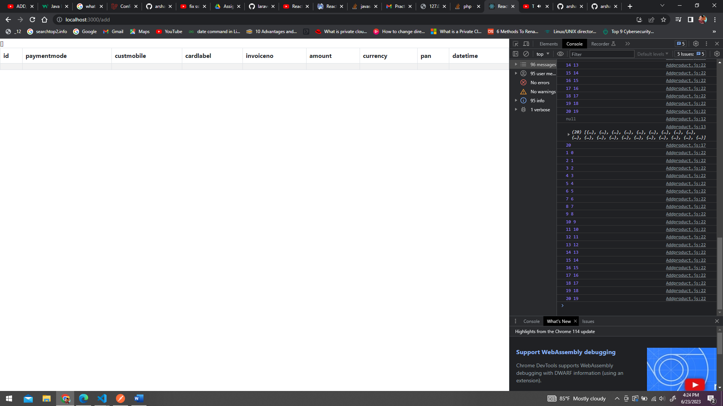

Later I saw the requirement to display every transaction and when the transaction is clicked the transaction details should be displayed so I made another report as well.

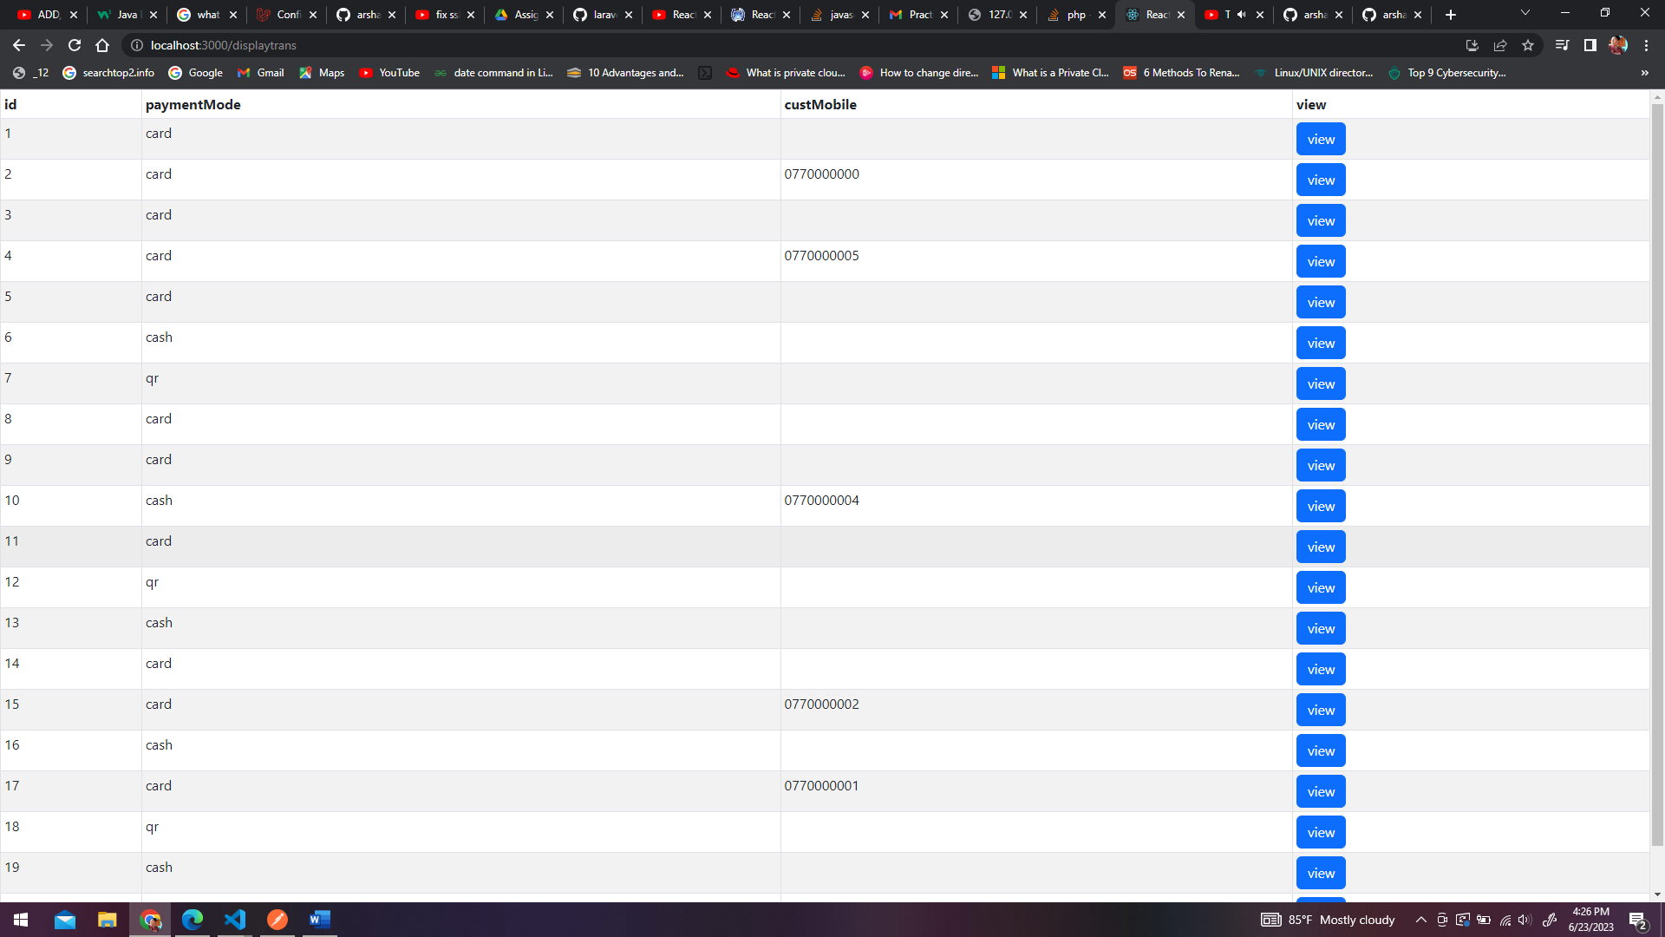

This displays some of the information and when the view button is clicked all the details of the transaction will be displayed for each transaction in a popup.

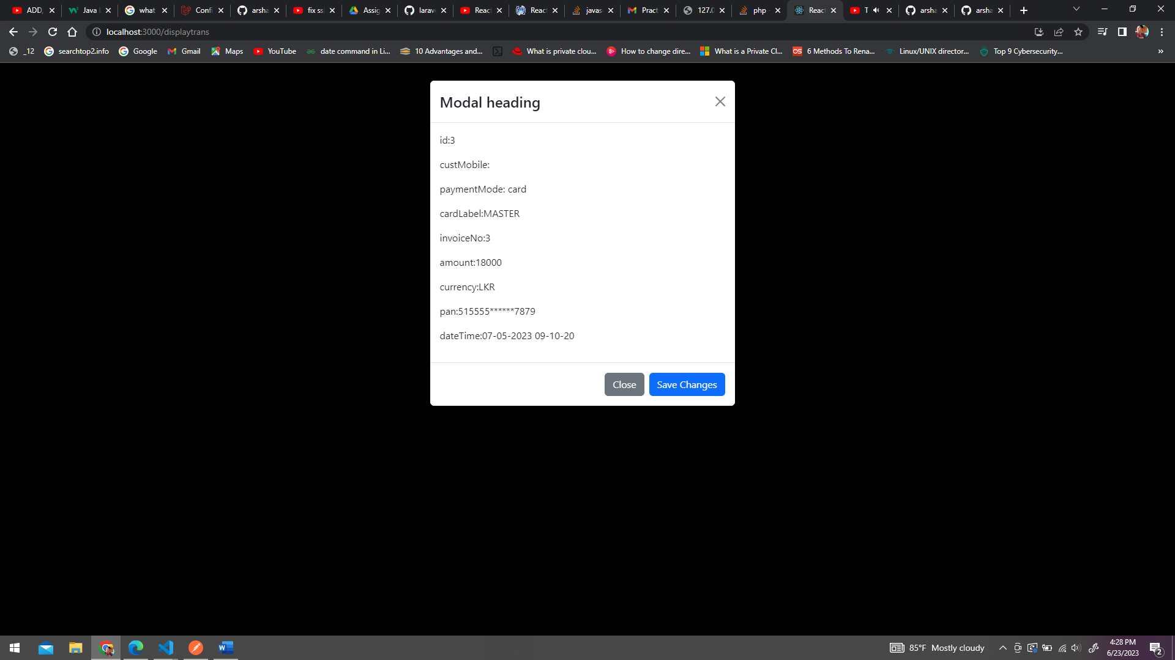

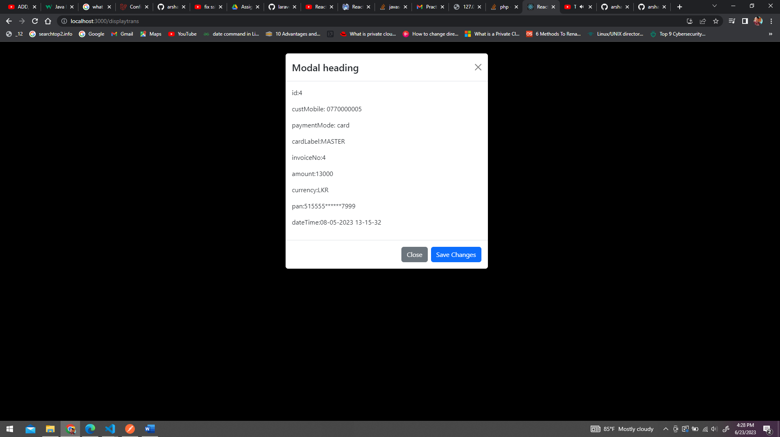

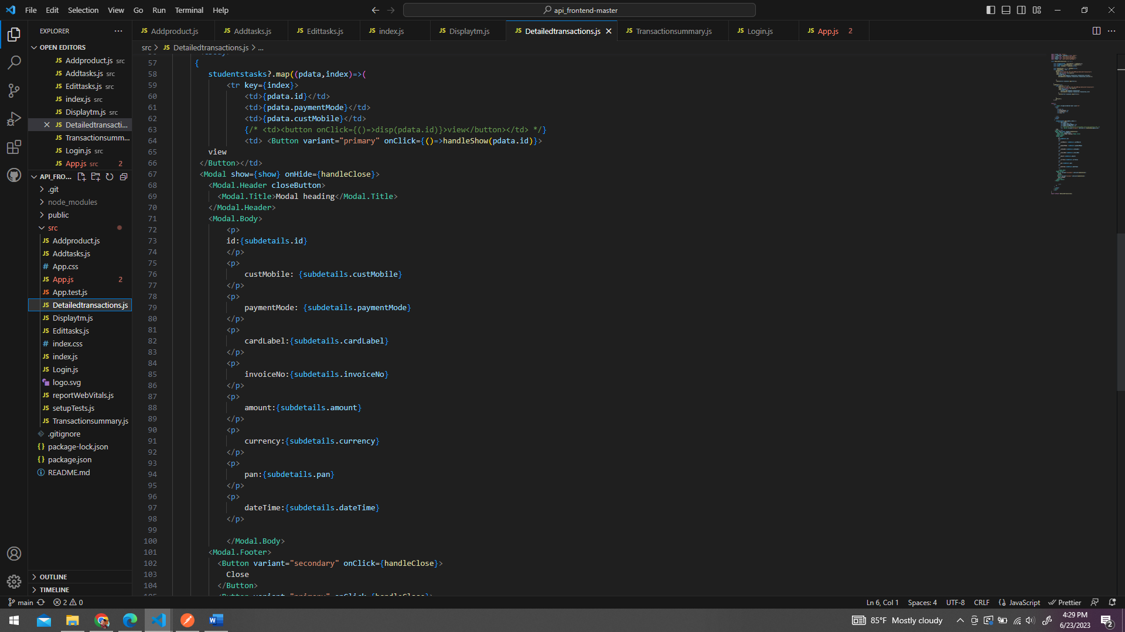

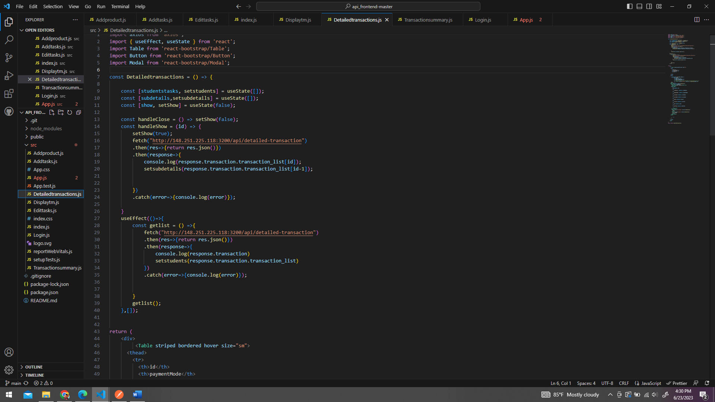

Transaction summary is also displayed in a separate page .

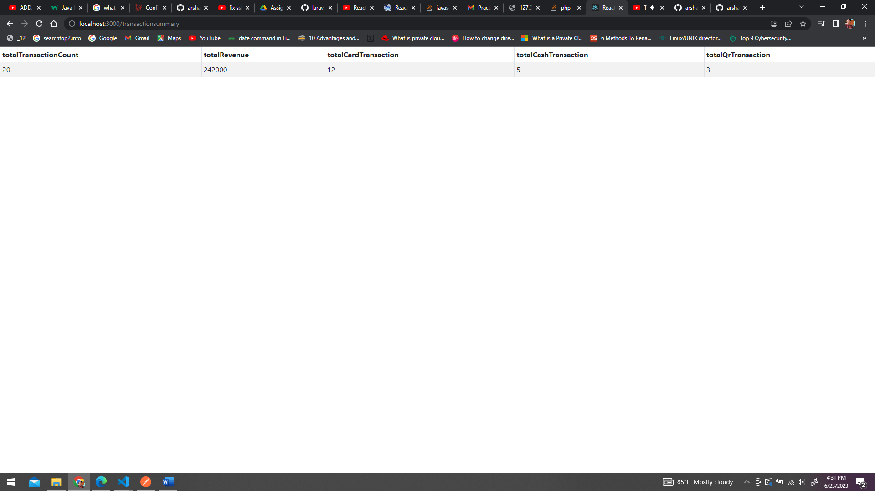

The third task was done using Laravel rest API and then the details were fetched and posted from react using axios and fetch .

The route:

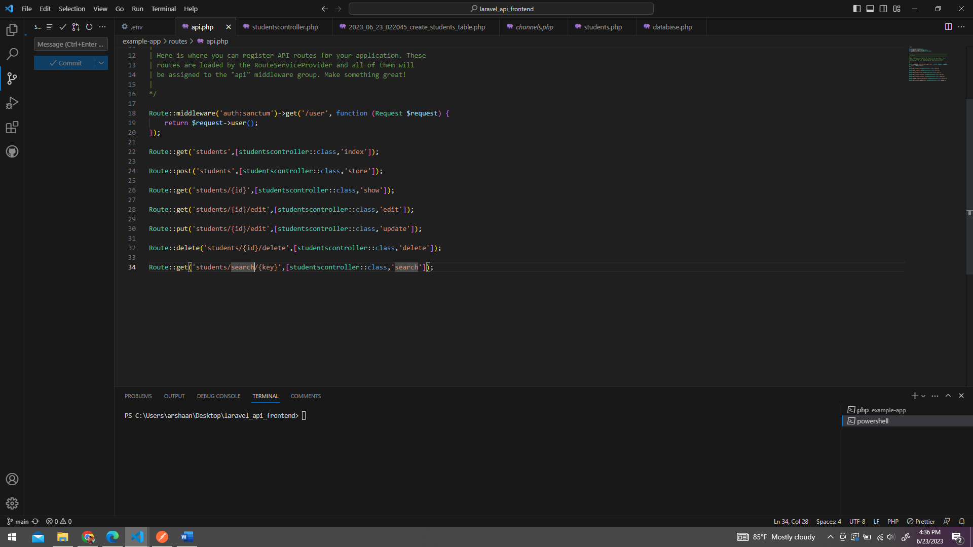

The model :

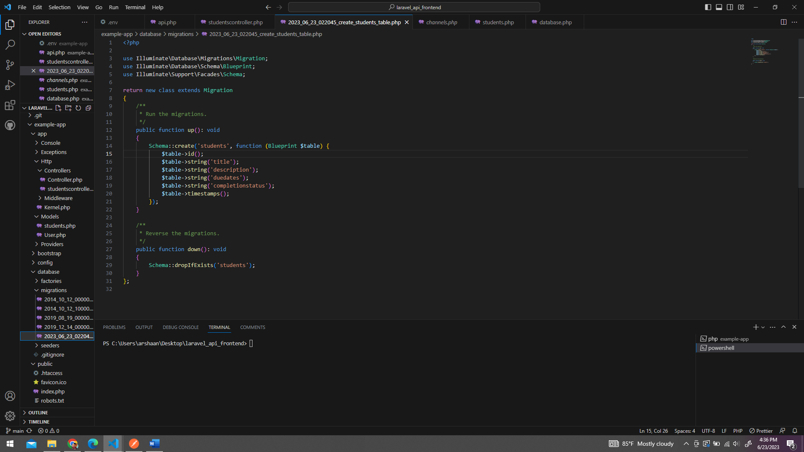

The controller :

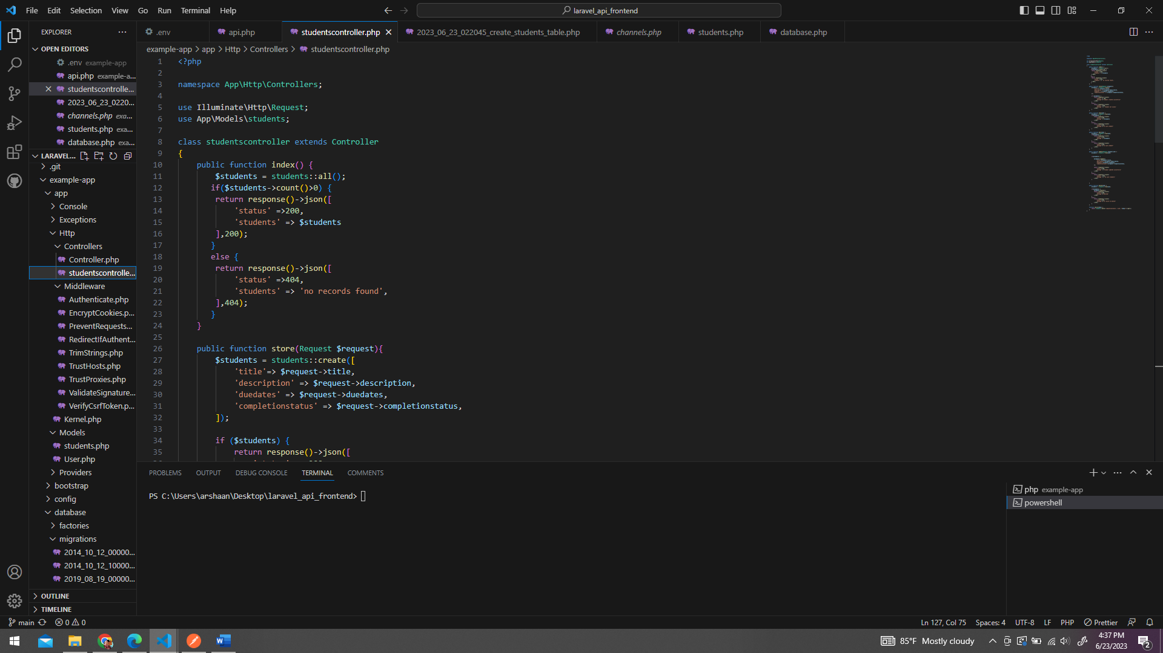

The database :

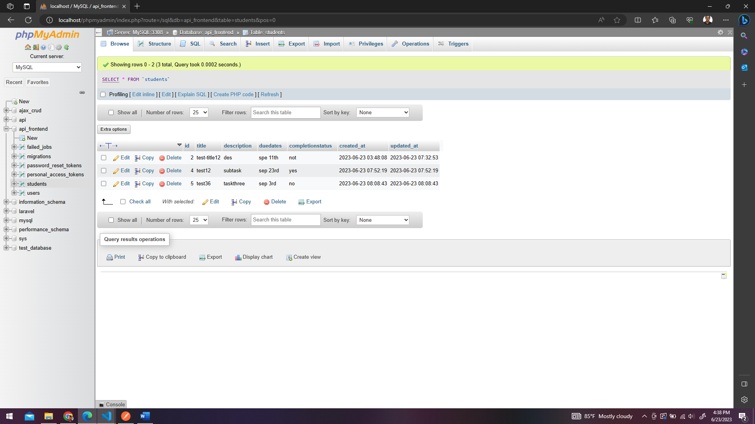

The details fetched from rest api to react

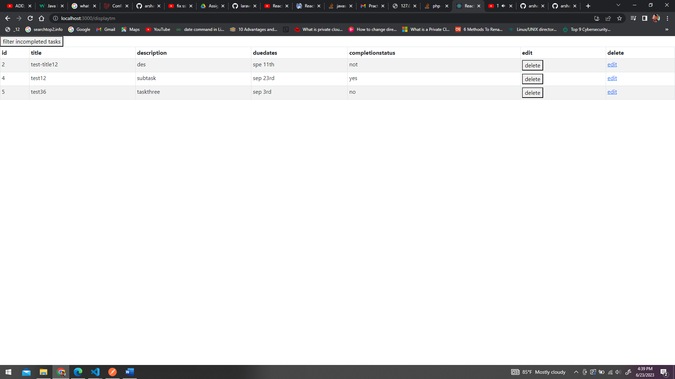

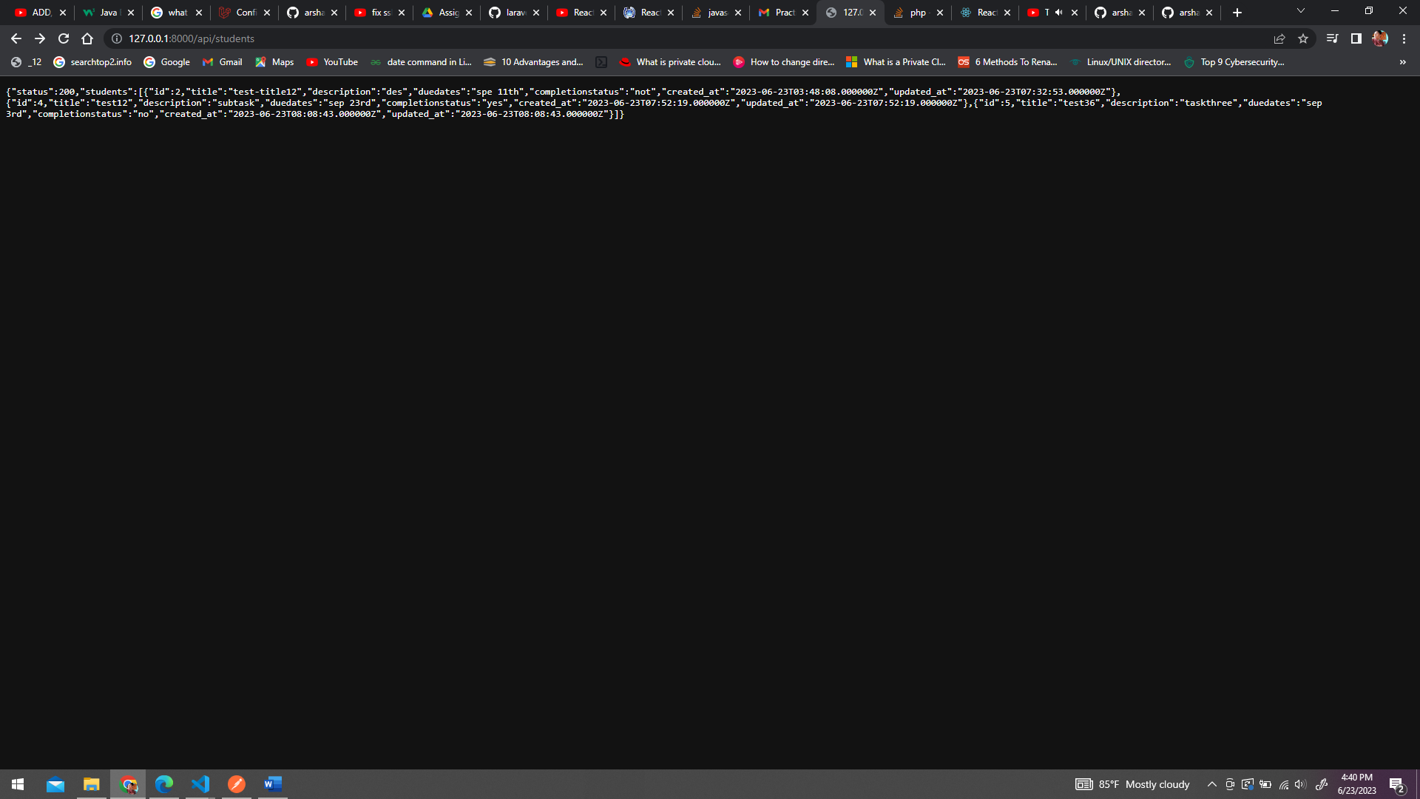

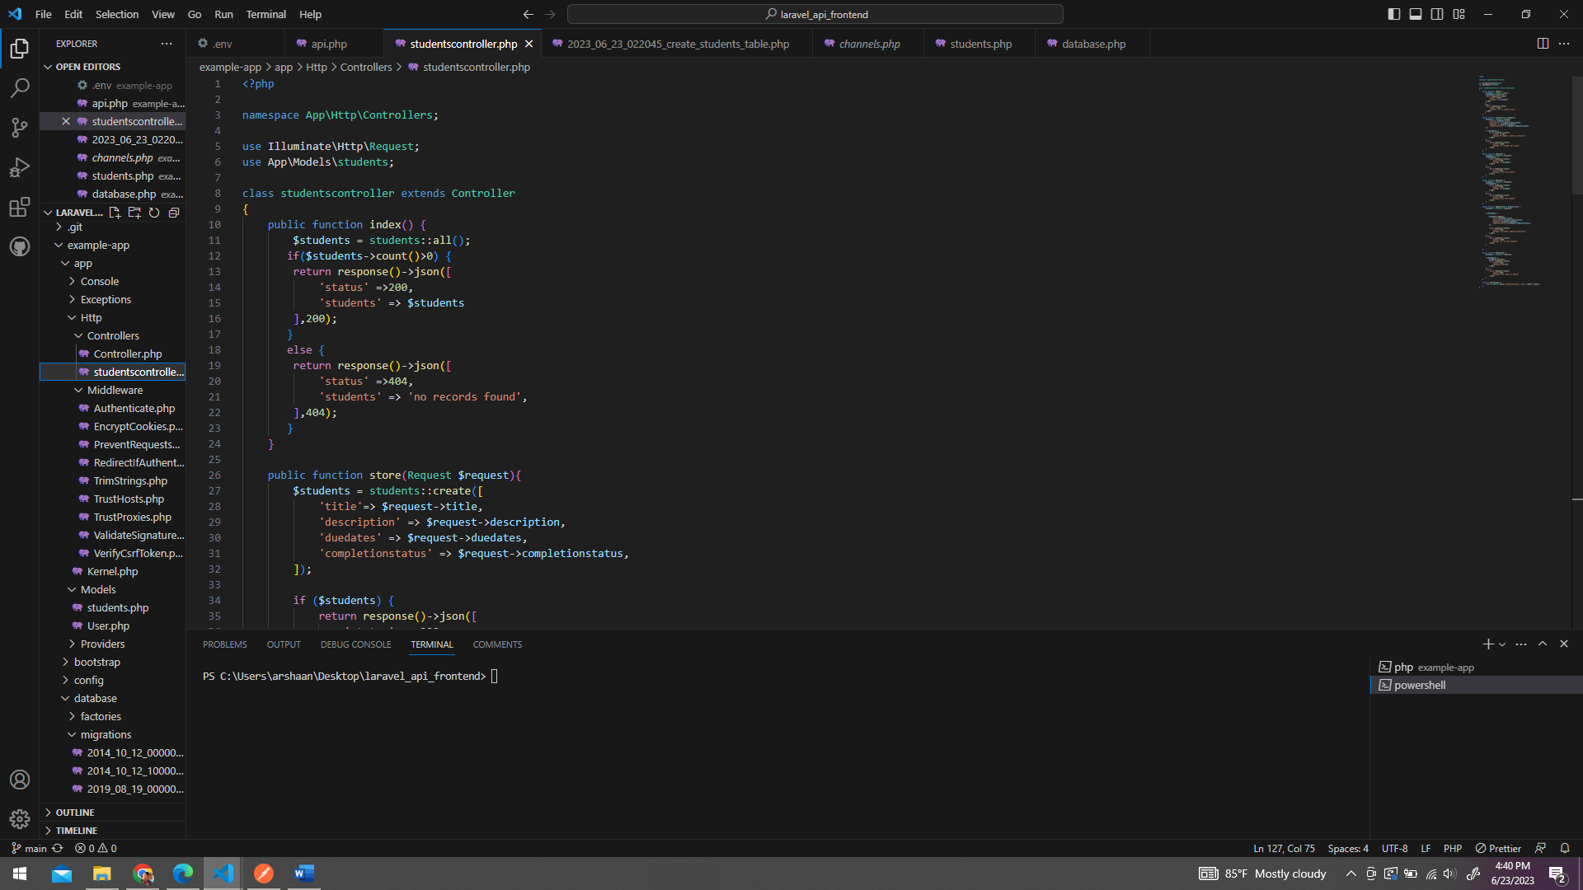

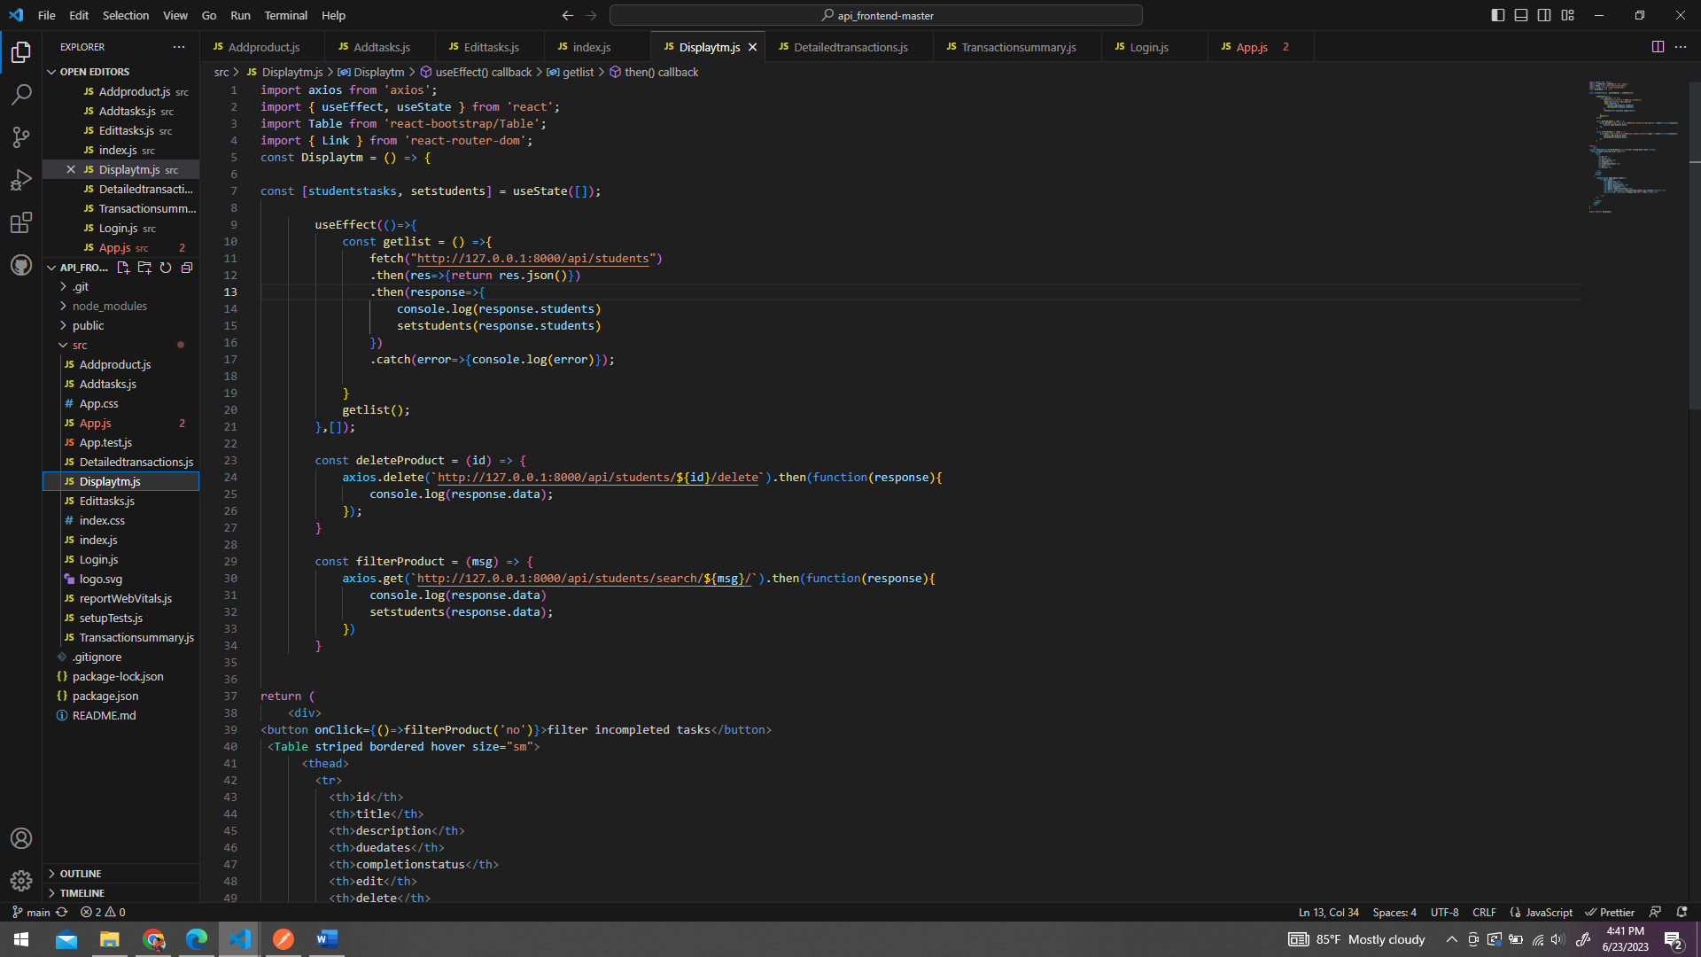

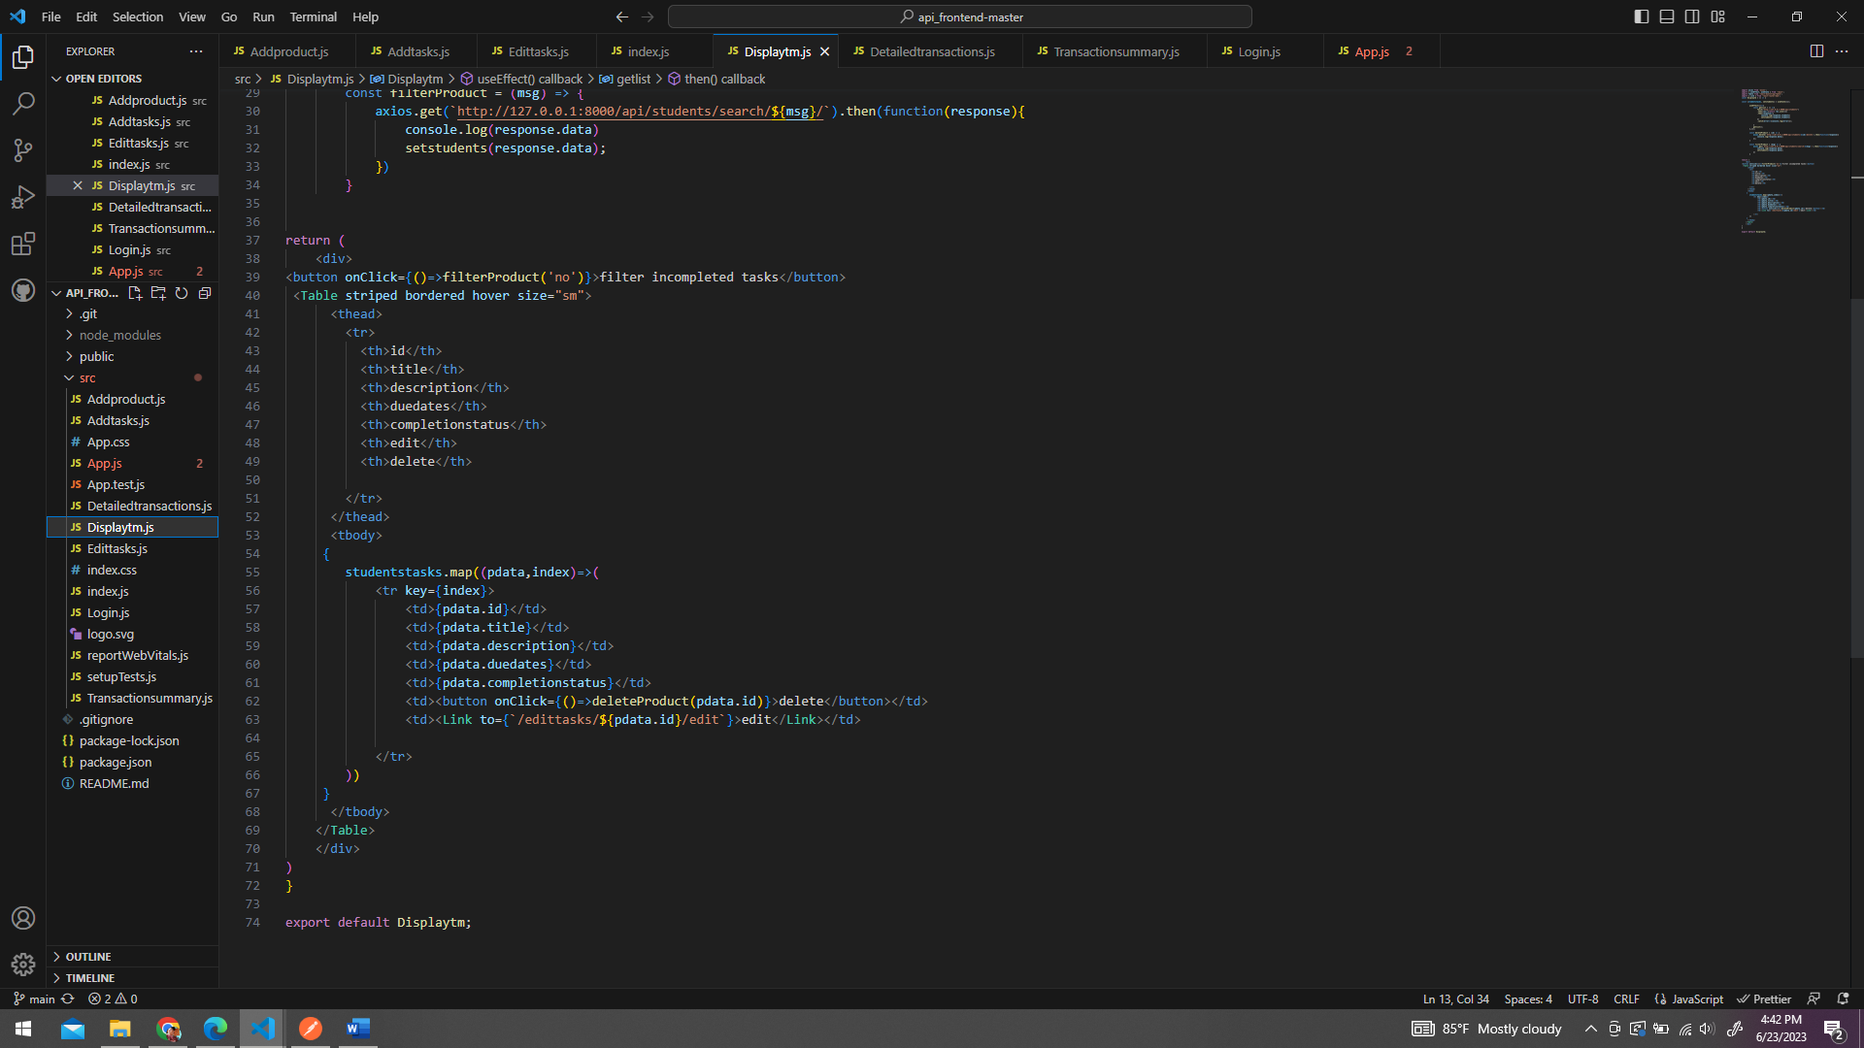

Add tasks:

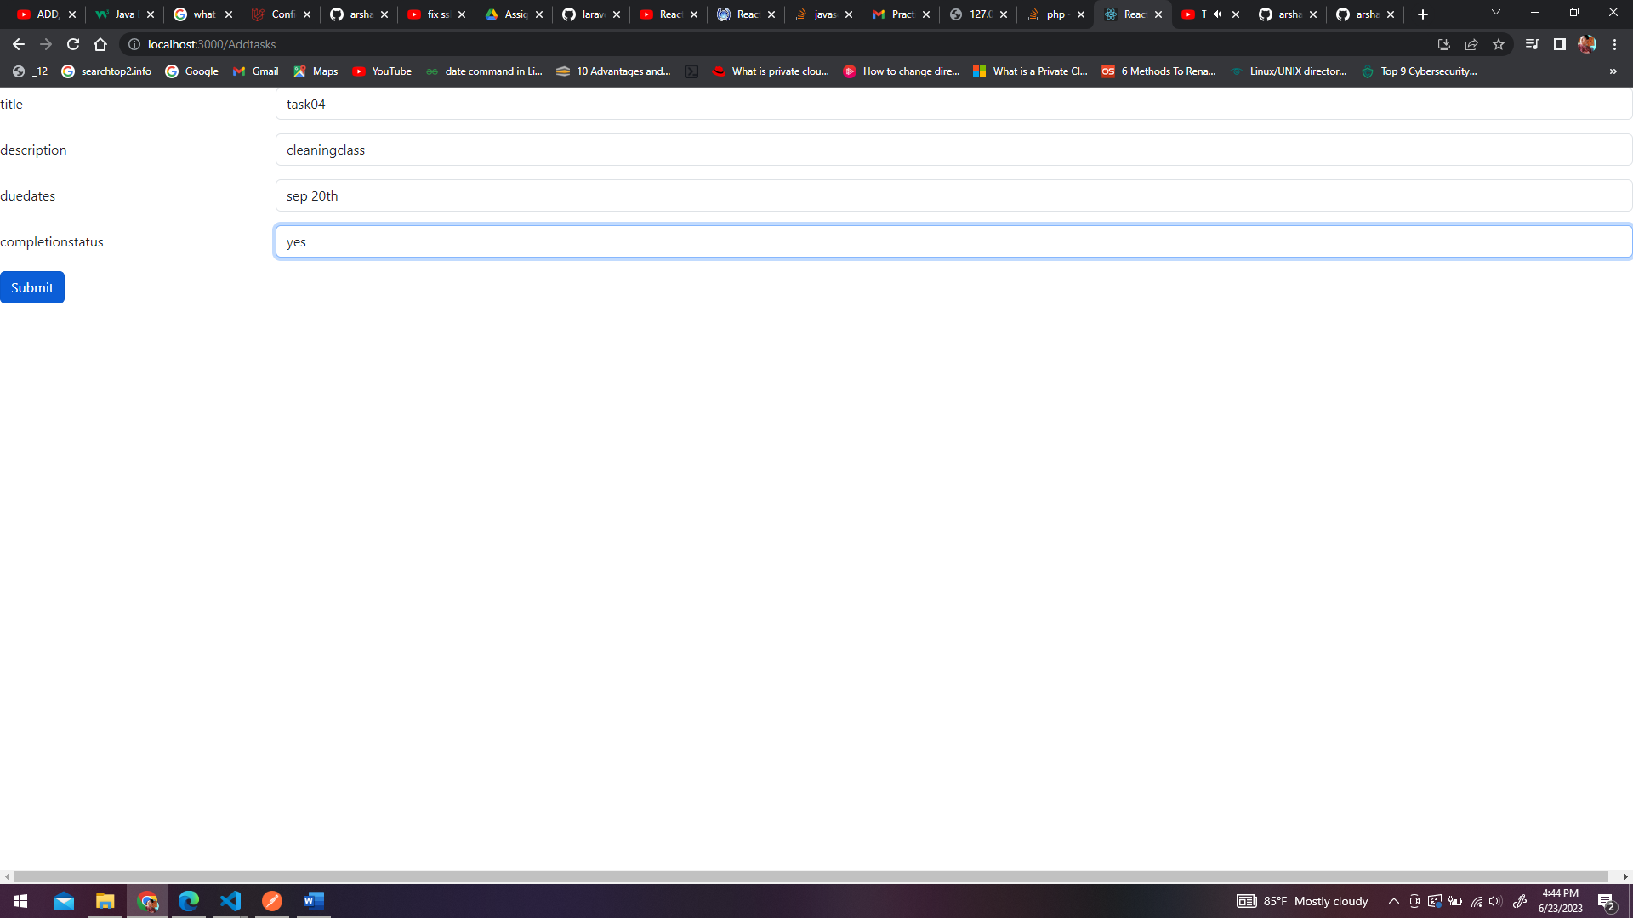

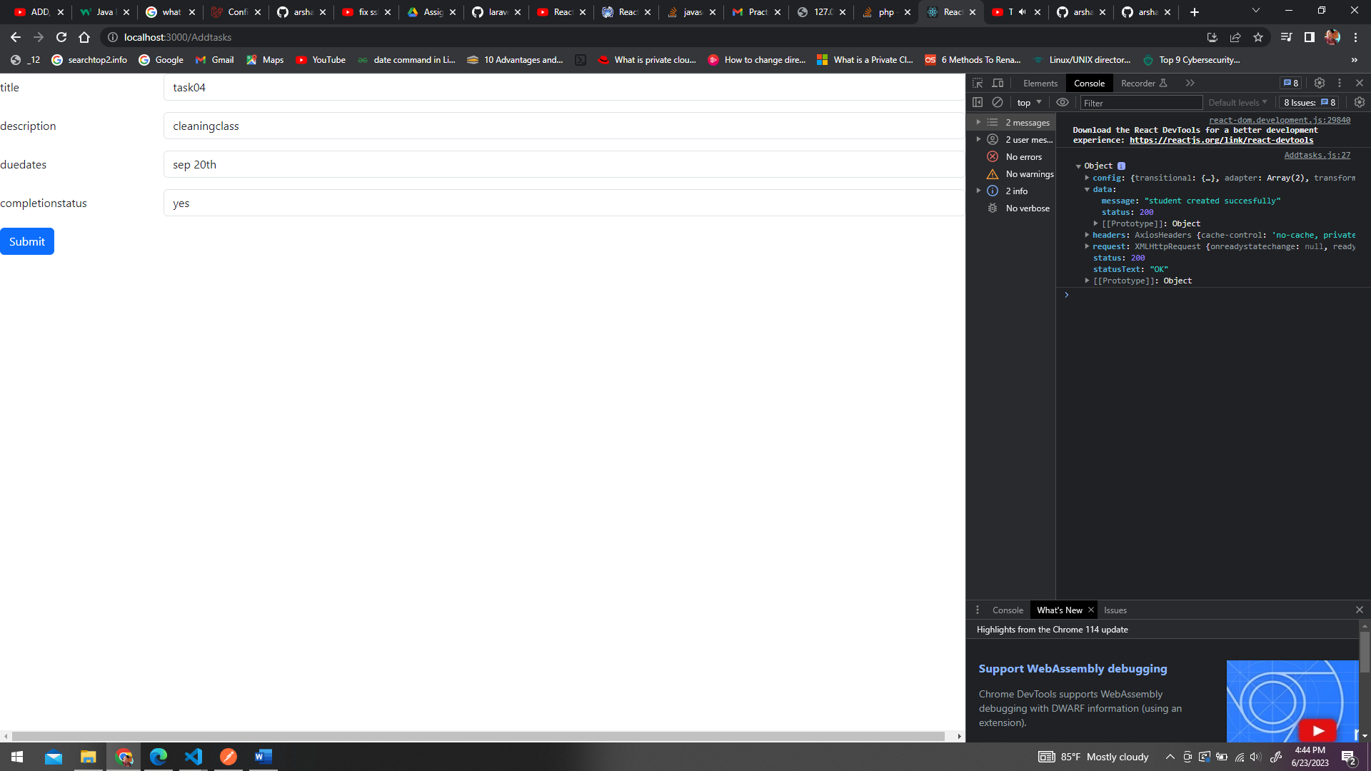

Edit details :

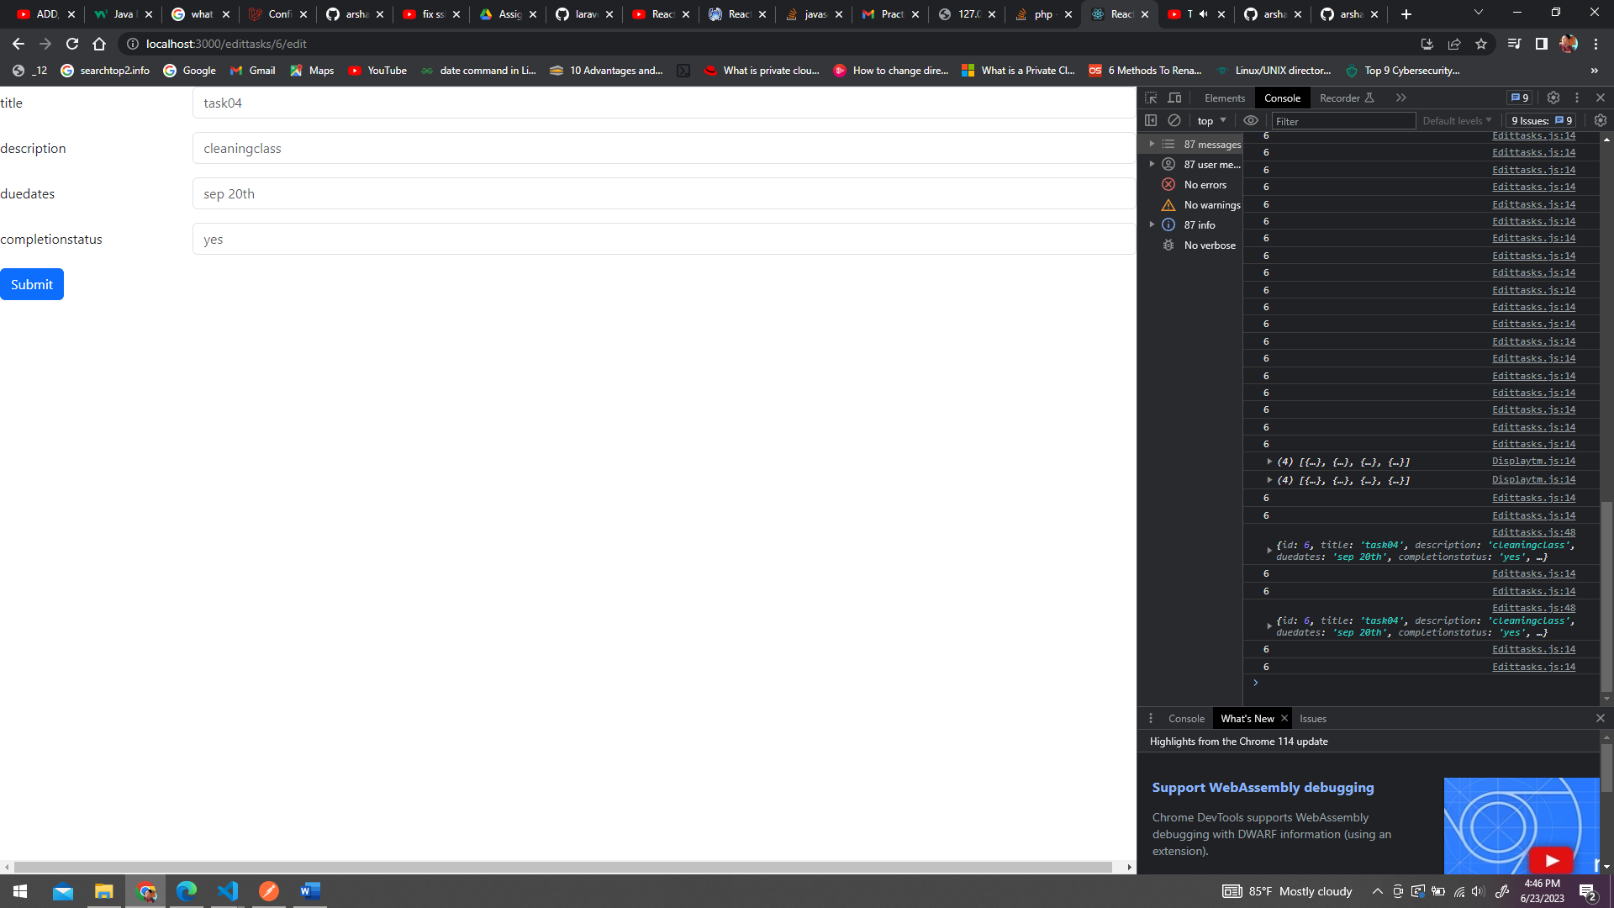

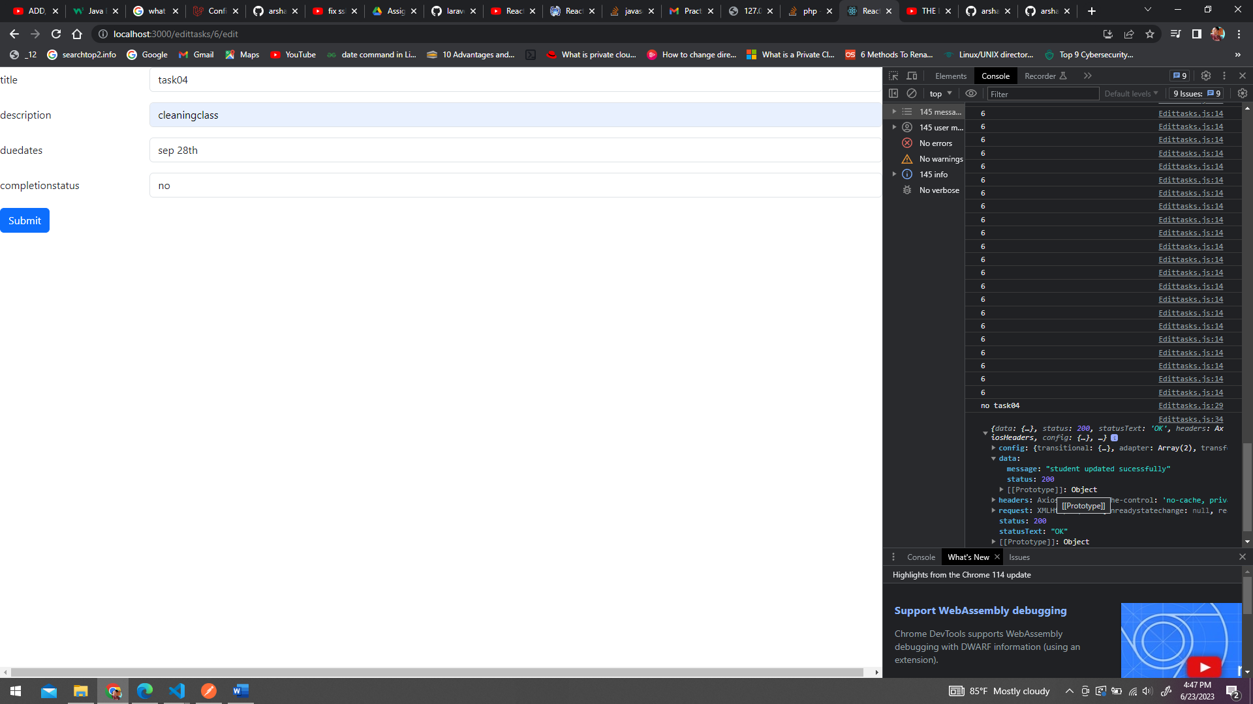

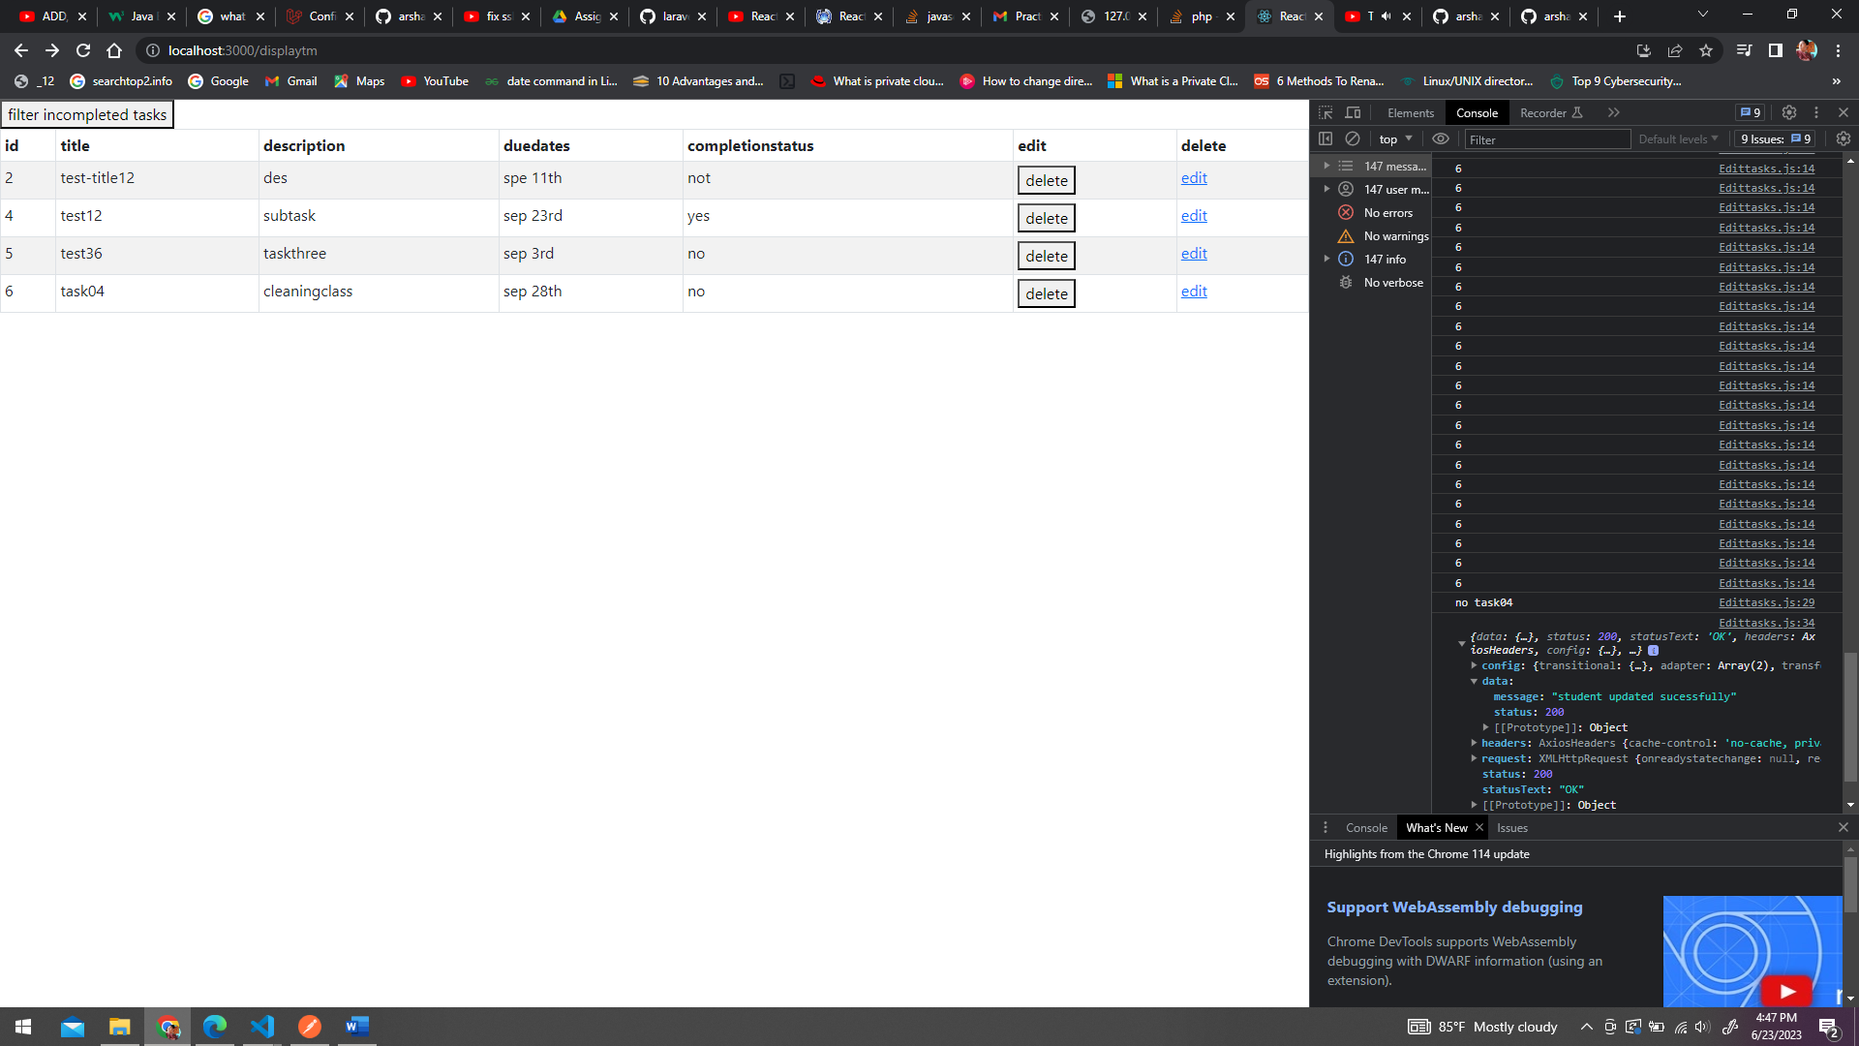

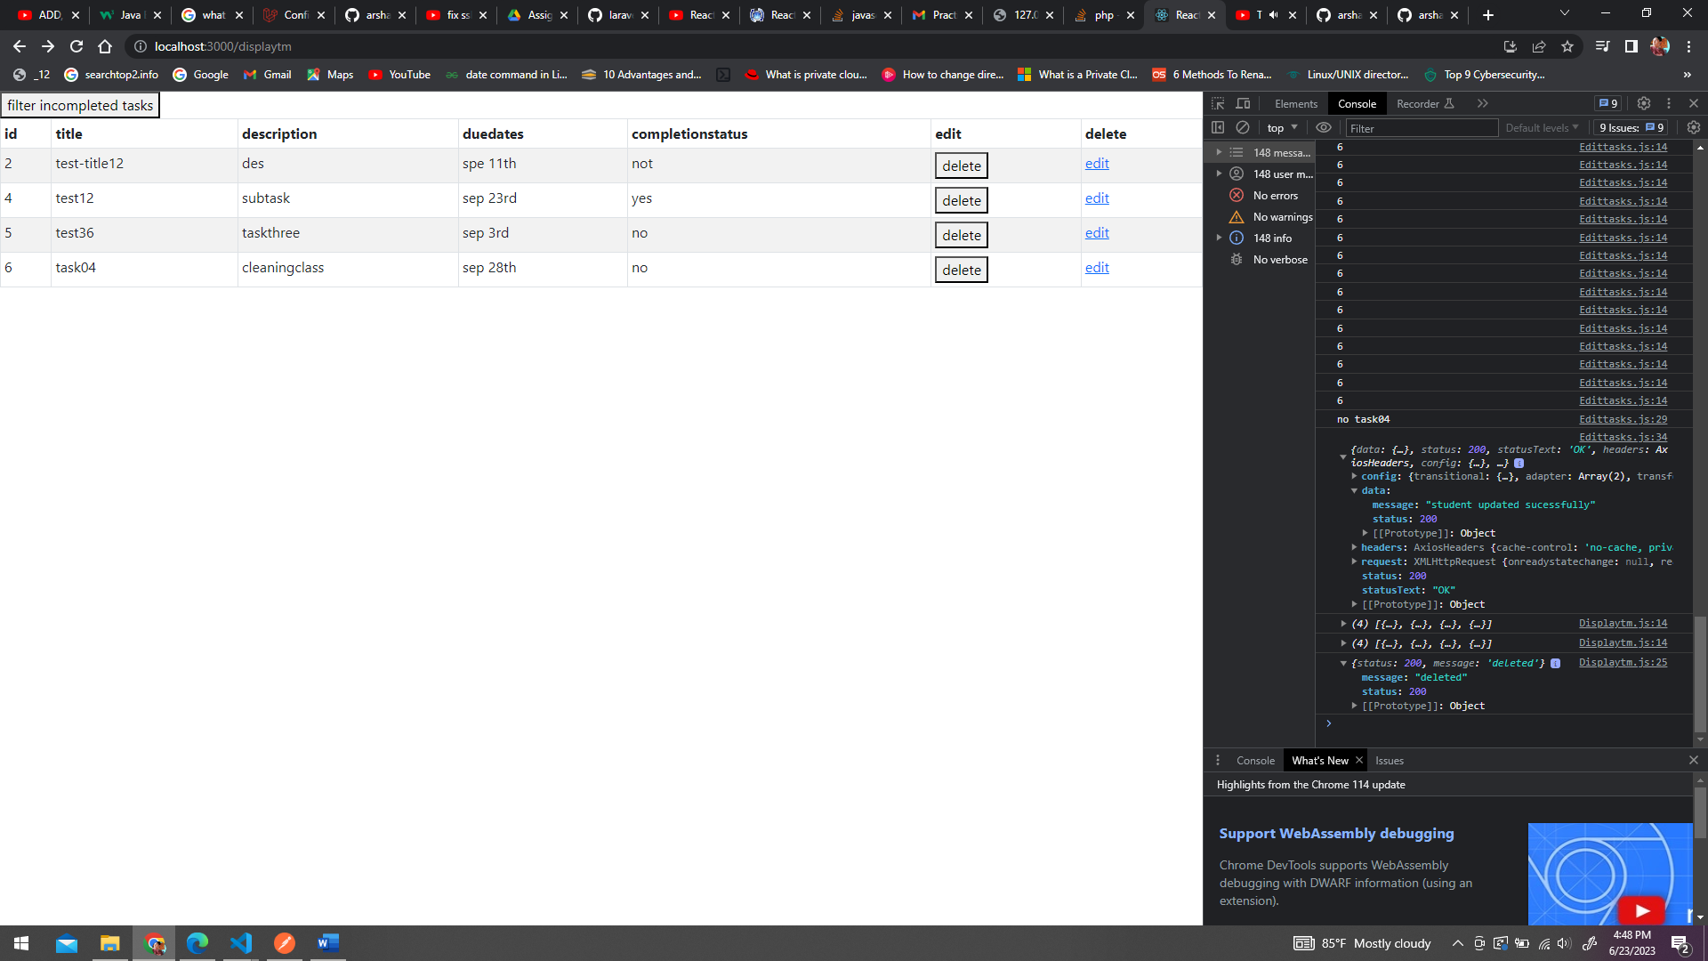

Delete record:

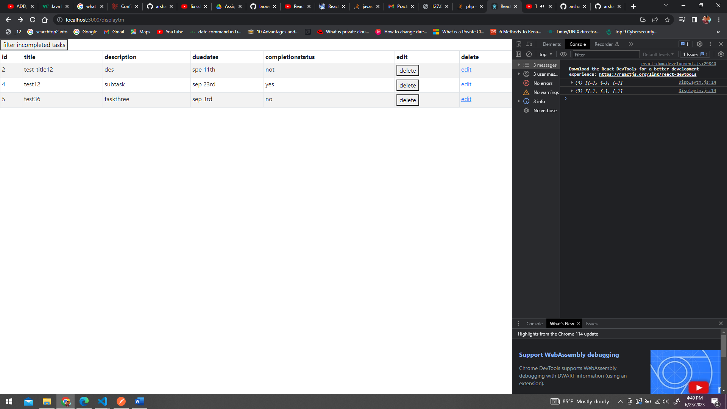

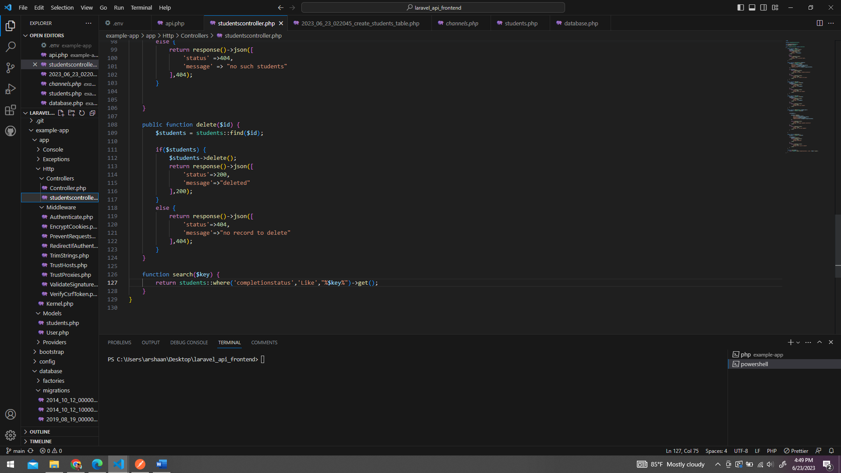

Filter records that are not completed:

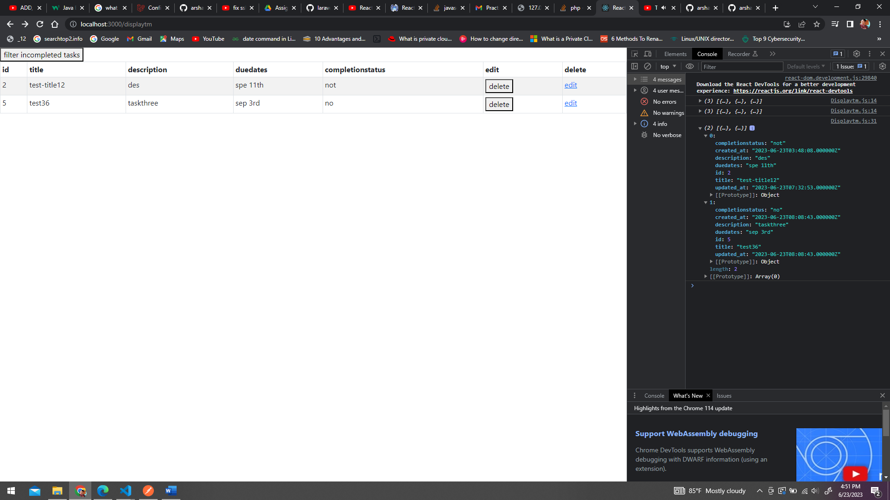

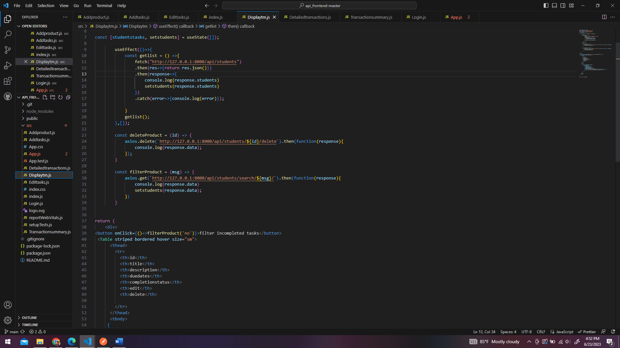

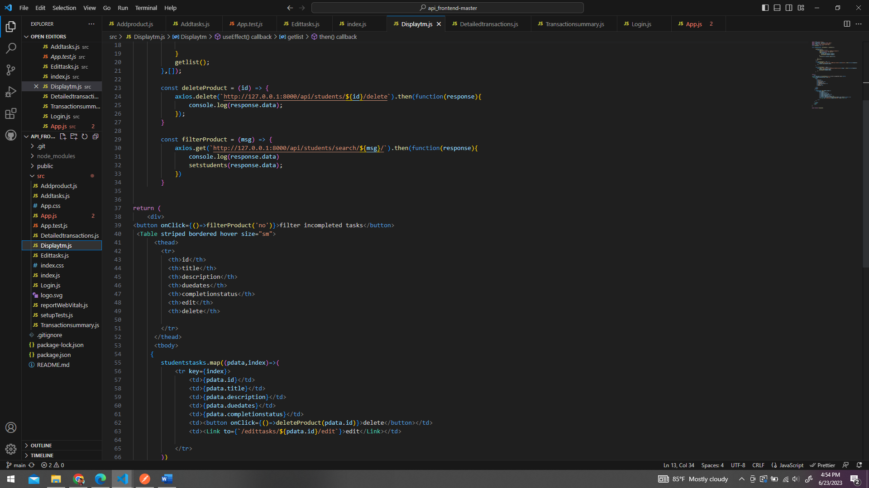

When the filter button is clicked a value called no will be passed and then that value will be passed to the route and to the controller and if the completion status is no it will only display those records

